**CHAP ROOM – MAP**

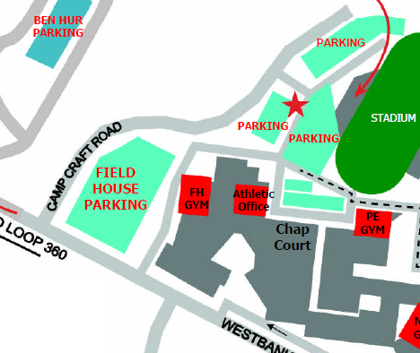

Chap Room – Please enter through the front of school. Athletes will be waiting at the doors to direct you to the room. Room 245