Unit Test Two Review

Multiple Choice
Identify the letter of the choice that best completes the statement or answers the question.

____ 1. When shoes at a local shoe store went on sale at 50 percent off the regular price, the store sold almost every pair of shoes it had in less than a day. By the time the stock was replenished, the sale was over and very few shoes were purchased. Which of the following does this illustrate?
a. | the income effect | c. | the law of demand
b. | the law of discounts | d. | the substitution effect

Market Demand Schedule
Price of a  slice of pizza | Quantity  demanded per day
$.50 | 300
$1.00 | 250
$1.50 | 200
$2.00 | 150
$2.50 | 100
$3.00 | 50

____ 2. Franco’s Pizzeria sells slices of pizza for $2.00. According to the market demand schedule and assuming ceteris paribus, what happens when Franco’s raises the price to $2.50 a slice?
a. | The quantity demanded per day stays the same.
b. | The quantity demanded falls from 100 slices a day to 50 slices a day.
c. | The quantity demanded falls from 150 a day to 100 a day.
d. | The quantity demanded increases to 250 a day.

____ 3. Mariah is buying fewer boxes of macaroni and cheese, used cars, fast-food dinners, and generic products because her income rose. This shift in the demand curve caused by Mariah’s income has resulted in
a. | a decreased demand for inferior goods.
b. | a decreased demand for tangible goods.
c. | an increased demand for normal goods.
d. | a decreased demand for expendable goods.

____ 4. Which of the following is NOT a factor affecting elasticity?
a. | availability of substitutes
b. | the good’s relative importance
c. | whether the good is a necessity or a luxury
d. | the good’s price range

____ 5. According to the law of supply, the higher the price,
a. | the more consumers are willing to pay.
b. | the larger the quantity produced.
c. | the smaller the quantity produced.
d. | the more the availability of a good is reduced.

Marginal Product of Labor
Labor  (number of  workers) | Output  (beanbags  per hour) | Marginal  product  of labor
0 | 0 | —
1 | 4 | 4
2 | 10 | 6
3 | 17 | 7
4 | 23 | 6
5 | 28 | 5
6 | 31 | 3
7 | 32 | 1
8 | 31 | –1

____ 6. According to the graph of marginal product of labor for a company that makes beanbags, which of the following situations is created when the fourth through seventh workers are hired?
a. | increasing marginal returns
b. | marginal product of labor specialization
c. | negative marginal returns
d. | diminishing marginal returns

____ 7. According to the graph, which of the following happens when an eighth person is hired at the beanbag company?
a. | A positive marginal product of labor is created.
b. | A negative marginal return is created.
c. | The output of beanbags is 28 per hour.
d. | The output of beanbags stays the same.

____ 8. In which category do subsidies, excise taxes, and regulation belong?
a. | effects of rising costs
b. | limitations on imports
c. | government’s influence on supply
d. | benefits of marginal costs

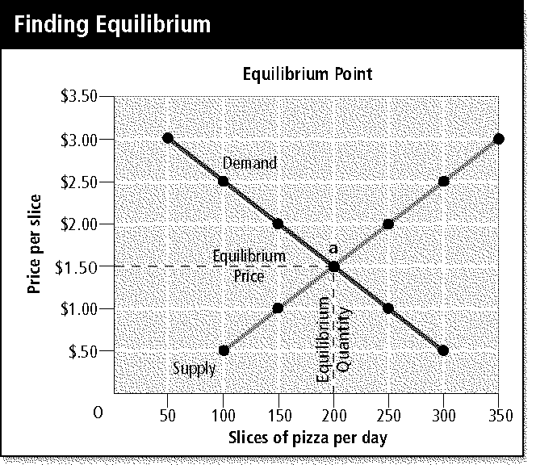

____ 9. Study the graph showing the equilibrium point for a pizzeria. Which of the following can be said about the equilibrium price and the equilibrium quantity?
a. | The quantity supplied and the quantity demanded are equal at 200 slices per day.
b. | The quantity demanded and the quantity supplied are equal at $2.00 per slice.
c. | The quantity supplied is not equal to the quantity demanded in this market, which should be at 200 per day.
d. | The maximum quantity demanded, 350 per day, is more than the quantity supplied.

____ 10. Which of the following government actions is an attempt to control the high cost of rent for lower-income families, and what has been the result of this action?
a. | Rent controls; high-income families are denied rental housing.
b. | Price ceilings; few renters with the greatest need benefit from the program.
c. | Rent ceilings; landlords can no longer discriminate.
d. | Price floors; the supply of apartments rose.

____ 11. Which word can be used twice to BEST complete this sentence? When supply ____, prices fall, and quantity demanded ____ to reach a new equilibrium.
a. | increases | c. | levels
b. | decreases | d. | reverses

____ 12. Factors that make it difficult for new firms to enter a market are called
a. | start-up costs. | c. | perfect competition.
b. | barriers to entry. | d. | commodities.

____ 13. A firm sells natural gas to a city for one price and sells the same gas to an outlying village at another price. What is this practice called?
a. | oligopoly | c. | differentiation
b. | monopoly | d. | price discrimination

____ 14. What is an oligopoly?
a. | an agreement by a formal organization of producers to coordinate prices and production
b. | a market structure in which a few large firms dominate the market
c. | a market structure in which two firms have a price war
d. | a market structure in which a single firm dominates the market

____ 15. Which of the following is one market trend that results when a monopolistically competitive firm starts earning profits well above its costs?
a. | The firm would become an oligopolistic firm because it has effectively eliminated the competition and now dominates the market alone.
b. | The firm would try to lure 100 percent of customers by flooding the market with defective products.
c. | Fierce competition would encourage rivals to create new ways to differentiate their products and lure customers to them.
d. | The firm would eventually go out of business because demand would decrease.

You will have graphs on Demand/ Supply/ Equilibrium

You will have problems on Elasticity

You will have one situation where you have to chart and predict profit maximization, worker efficiency and diminishing marginal return

Study all your packets and practice quizzes in Chapters 4, 5 and 6

I will answer any questions you have on Thursday in class

Unit test is Friday the 16th

