Chapter two review

Multiple Choice
Identify the letter of the choice that best completes the statement or answers the question.

____ 1. Which of the following is NOT characteristic of a centrally planned economy?
a. | The central government owns all land and capital.
b. | The central government makes all economic decisions.
c. | Each collective or factory sets its own goals.
d. | Each person is assigned a job.

____ 2. What is the struggle among various producers for the consumer’s business called?
a. | socialism | c. | incentive
b. | competition | d. | self-regulation

____ 3. Why does even a free market economy need some government intervention?
a. | to provide for things that the marketplace does not address
b. | to ensure that the government has the freedom to tax as necessary
c. | to make sure that the government can fulfill its needs for military personnel
d. | so that the government has some control over factor resources

____ 4. Which of the following is NOT a key economic question?
a. | What goods and services should be produced?
b. | How should these goods and services be produced?
c. | Who consumes these goods and services?
d. | How should it be ensured that goods and services are paid for?

____ 5. What does the process of specialization do for an economy?
a. | It eliminates unemployment. | c. | It fosters competition.
b. | It makes it more efficient. | d. | It makes it easier to control.

____ 6. How could the Chinese economy be characterized?
a. | free market
b. | centrally planned
c. | mixed, but on the side of centrally planned
d. | mixed, but on the side of free market

____ 7. What is the product market?
a. | the market in which payments are received for selling products to consumers
b. | the market in which income is received for supplying land, labor, or capital
c. | the market in which firms purchase the factors of production from households
d. | the market in which households purchase the goods and services that firms produce

____ 8. In what kind of an economy does the government make all the decisions?
a. | socialist | c. | centrally planned
b. | laissez faire | d. | free enterprise

____ 9. What is the purpose of competition?
a. | to act as a regulating force in the marketplace
b. | to cause producers to attempt to put each other out of business
c. | to cause buyers to have to be careful about spending their money
d. | to act as a motivating force behind the free market

____ 10. What is the function of an economic system?
a. | to make sure all people have equal access to goods
b. | to produce and distribute goods and services
c. | to give all producers the same access to consumers
d. | to make sure people are paid for their labor

____ 11. Which of the following is a condition that most people would NOT expect the safety net of the government to provide for?
a. | injuries | c. | natural disasters
b. | joblessness | d. | low income

____ 12. How would the economy of Canada be likely to be characterized?
a. | free market
b. | centrally planned
c. | mixed, but on the side of centrally planned
d. | mixed, but on the side of free market

____ 13. What is an important advantage of a free market?
a. | It does not change unless the government directs it.
b. | It offers a wide variety of goods and services.
c. | It is easy to regulate.
d. | It protects the less fortunate.

____ 14. Who was the leader that introduced communism and central planning to the former Soviet Union?
a. | Karl Marx | c. | Vladimir Lenin
b. | Joseph Stalin | d. | Friedrich Engels

____ 15. What is the motivating force behind the free market?
a. | competition | c. | self-interest
b. | the invisible hand | d. | specialization

____ 16. A person who believed in the doctrine of laissez faire would disapprove of
a. | the invisible hand of the marketplace.
b. | consumer sovereignty.
c. | self-interest as the motivating force in the free market.
d. | government funding of education.

____ 17. Suppose there is a family in which all the boys are expected to become farmers when they are adults, just as their fathers and grandfathers did. In which kind of economy do they participate?
a. | false economy | c. | traditional economy
b. | command economy | d. | centrally planned economy

____ 18. Households pay firms for goods and services. Firms supply households with goods and services. The purchase and supply of goods and services takes place in the
a. | product market. | c. | after market.
b. | factor market. | d. | traditional market.

____ 19. Which of the following goals is difficult to achieve in a pure free market system?
a. | economic efficiency | c. | economic freedom
b. | economic equity | d. | economic growth

____ 20. A government prints and distributes posters to inspire workers to increase their productivity. In which kind of economy does this most likely take place?
a. | weak economy | c. | market economy
b. | traditional economy | d. | centrally planned economy

____ 21. A person believes that real equality can only exist when political equality is coupled with economic equality. This person believes that democratic means should be used to distribute wealth evenly throughout society. This person is a
a. | socialist. | c. | capitalist.
b. | communist. | d. | authoritarian.

____ 22. Collectives in the Soviet Union were inefficient producers of agricultural products. Why?
a. | The farms were too small to produce substantial crops.
b. | Most farmers were poor and had to pay for their own equipment, seeds, and fertilizer out of their own pockets.
c. | Farm workers had guaranteed incomes, so they had few incentives to produce more or better crops.
d. | Soviet central planners ignored the farms in favor of factories producing consumer goods.

____ 23. The economy of China is in transition. What does this mean?
a. | Investments are determined by state control instead of by private decision.
b. | The economy is moving from central planning toward a market-based system.
c. | Individual firms are in the process of being sold to the state.
d. | The government rarely interferes in the free market and is highly receptive to foreign investment.

____ 24. In which of the following lists of mixed economies does the market system dominate?
a. | France, Canada, South Africa, United Kingdom
b. | United States, United Kingdom, Singapore, Hong Kong
c. | Cuba, Greece, China, United States
d. | Russia, Peru, France, Canada

Matching

Identifying Key Terms
Match each term with the correct statement below.
a. | standard of living | f. | communism
b. | privatize | g. | laissez faire
c. | economic system | h. | collective
d. | self-interest | i. | product market
e. | safety net | j. | factor payments

____ 25. one’s own personal gain

____ 26. the income people receive for supplying such things as land, labor, or capital

____ 27. a situation in which households purchase the goods and services that firms produce

____ 28. the doctrine that government generally should not intervene in the marketplace

____ 29. level of economic prosperity

Identifying Key Terms
Match each term with the correct statement below.
a. | free enterprise | f. | socialism
b. | continuum | g. | transition
c. | incentive | h. | traditional economy
d. | safety net | i. | authoritarian
e. | collective | j. | standard of living

____ 30. government programs that protect people experiencing unfavorable economic conditions

____ 31. an economic system that permits the conduct of business with minimal government intervention

____ 32. an expectation that encourages people to behave in a certain way

____ 33. an economic system that relies on habit, custom, or ritual to decide questions of consumption and production of goods and services

____ 34. a philosophy based on the belief that democratic means should be used to distribute wealth evenly throughout a society

____ 35. a range with no clear divisions

____ 36. a period of change in an economy

Short Answer

Interpreting a Circular Flow Diagram

Circular Flow Diagram of a Market Economy
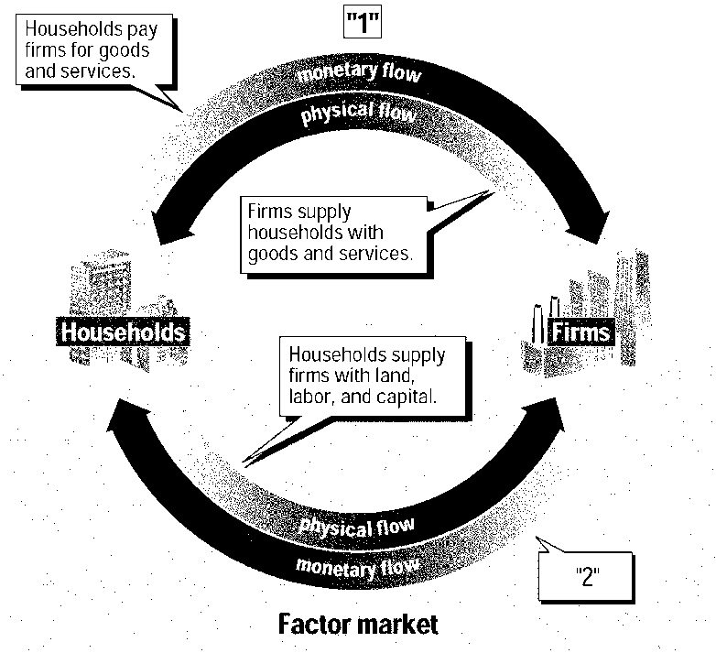
Figure 2.1

37. What does the upper half of Figure 2.1, marked “1,” represent?

38. According to Figure 2.1, what does the lower line of monetary flow, marked “2,” show?

Interpreting a Circular Flow Diagram

Circular Flow Diagram of a Market Economy
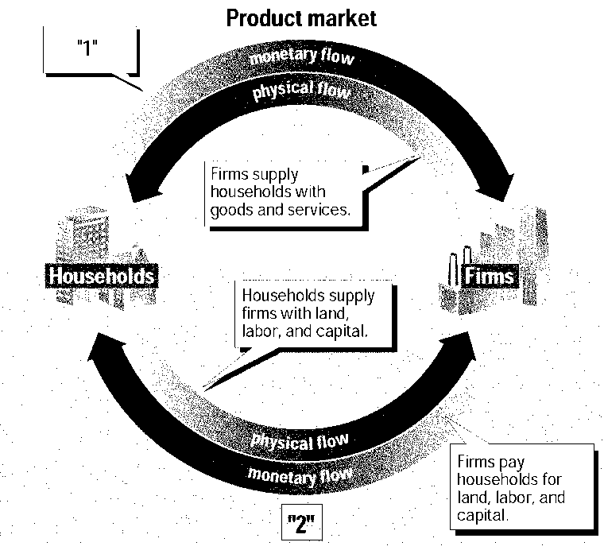
Figure 2.2

39. According to Figure 2.2, what does the upper line of monetary flow, marked “1,” show?

40. What does the lower half of Figure 2.2, marked “2,” represent?

