The Wealth Gap
A Group Assignment
Collaborative Solutions

What is the “wealth gap”? What does it look like?

- Wealth disparity, unequal distribution of wealth across the population, gulf between haves and have nots, the thinning out of the middle class.
- “Race to the bottom in jobs and wages since the global financial crisis”.
- “Rising tide lifts all yachts”
- 95% of all economic gains to the top 1% since ’09.
- 80% stock market wealth held by top 10%.
- 400 richest Americans have more wealth than the bottom 150,000,000 combined.
- 85 richest people on earth have more wealth than 3.5 billion of the poorest.
- Since the start of the crisis in ’08 the government has borrowed $6 trillion dollars and printed $7 trillion more. Where has this money gone?

Causes

- Government bailed out the rich (big banks, AIG) during the recession but did little for the poor except “income security” – food stamps, unemployment insurance
- Actions of the Fed benefited investors, little for workers.
- Demoralization associated with wage/income stagnation causes people to stop trying.
- Culture of dependency in the lower classes
- Globalization – the outsourcing/offshoring of good paying union factory jobs.
- Job loss associated with technology – creative destruction of jobs
- Nature of capitalism, rewarding what it rewards and punishing (or indifferent to) what it punishes.
- Skill set mismatch – disequilibrium regarding labor and employment
- American education system not producing what the economy needs. “Smarts gap”
- Opportunity inequality
- Education inequality
- Wages stayed static while productivity went up dramatically
- Concerted effort to de-unionize the American workforce
- Internal migration of jobs from union to non-union states.
- Meager job creation, “jobless recovery”

Observations / causal

- The Great Recession exposed issues in our economy that were a long time in the making.
- Concentration of wealth at the top is not sustainable. If nothing changes even more wealth will accumulate at the top. Not enough aggregate demand.
- Recession hurt every income category but especially the poor minorities.
- Poor have never inherited anything, no leg up.

Politics of the gap

stereotype

- The rich elites control the government and make the rules. The rules benefit the rich as a result. (Low capital gains tax, lax regulation of the financial industry, tax loopholes, incentives to outsource workers and earnings).
- Government needs to take assertive action, stimulus spending.
- Raise taxes on the rich.
- If the 1% are the job creators then where are the jobs? 1% has made out like bandits in the last five years.
stereotype

- Wealth gap overstated, normal in capitalism.
- Lower class/poor Americans aren’t working hard enough.
- Evidence of government enabling the poor via safety net programs.
- Don’t raise taxes, enlarge the economic pie!
- Reduce taxes further, eliminate burdensome regulations – the 1% are the nation’s job creators.

Solutions

- Address the mobility (upward mobility) issues.
- Raise the minimum wage.
- Raise taxes on capital gains and funnel the money straight into education.
- German style worker council/unions.
- Raise taxes on the upper income earners.
- Seriously revamp/revisit/reimagine our entire educational system.
- Require financial literacy education
- Make college affordable.
- Retain the incentives found in the capitalist system.
- Extend unemployment benefits.
- Close tax loopholes that benefit only the few.
- Smart stimulus spending on real infrastructure projects.
- Incentivize companies with tax credits to stay in the U.S. and hire American workers.
- Create a pension plan for low wage workers – portable (take from job to job) savings program. “MyRA”
- Tax corporations by size – proportionally progressive tax system, tax size and profits.
- Wait for the Malthusian Solution

What does this graph seem to imply as a solution? Possible in current political environment?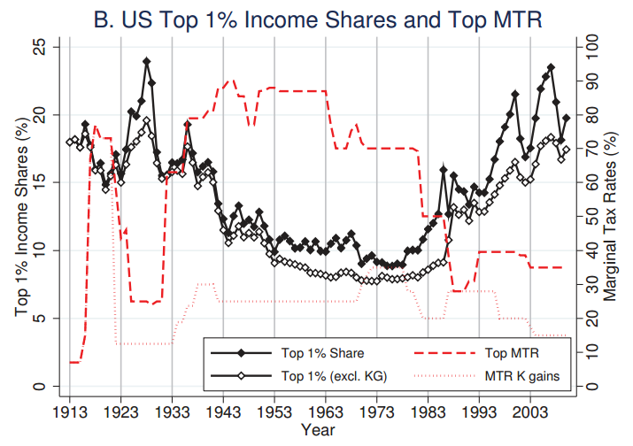

Classical Economics:
- Markets are self-correcting, full employment always prevails in the end.
- Any period of unemployment will cause wages to drop, new equilibrium achieved.
- Unemployed experience joblessness and will accept new wages. Some will be motivated to rise above this condition.
- Owners will begin to rehire when labor costs (inputs) pass a cost benefit analysis.

The “Grand Bargain”
- Wages high enough to allow workers to purchase what they produce. Demand grows.
- High marginal tax rates on the rich; wealth is spread out, society benefits.
- CEO pay a few times that of factory floor worker, not 100s of times.
- Significant government expenditure on real infrastructure that benefits all – interstate highways, public education, science…
- Banks regulated, controlled speculation (conditions of “moral hazard” minimal)

