Refueling Protocol

What: A plan to speed recovery from hard exercise by refueling muscles completely between hard workouts.

Why:
- Supports intense training
- Reduces recovery time
- Muscle repair and tendon growth
- Prevention of injury and illness

Which Workouts:
- 8 miles or longer
- 60+ continuous minutes
- Hill & speed work
- Races

Refueling Protocol

Protocol:
1. Time Frame: Within 30 minutes of a hard workout or race

2. What to Eat: Based upon body weight
- 100lb athlete - 50g carb/10g protein
- 150lb athlete - 75g carb/15g protein

3. Drink: 16-24 oz. of fluids per pound of sweat loss

4. Repeat: Another meal within 2 hours of exercise

Recovery Food:
50g carbs / 10 g protein
- Powerbar and small sport drink
- Slimfast / carnation instant breakfast
- 12 oz chocolate milk
- Bagel and peanut butter

Eating Schedule for Morning Races
Racing Muscles - Fueled by dinner and night snack
Dinner: Eat high carbohydrates, low fat and drink lots of fluids
- Pasta/meat sauce, salad, bread, fluids
- Chicken, potato, veggies, cookie, fluids
- 12" sub, pretzels, cookie, fluids

Night Snack: Essential for runners who skip breakfast
- Cereal, milk, toast
- Sandwich & banana
- Energy bar & sport drink
Breakfast: Fuels pre-race warm up & glycogen for racing
- Sport bar / drink
- Cereal/ toast
- Toast / fruit
Pre-Race Eating
Below are guidelines for timing pre-race meals. All athletes are different and our goal is to find what foods and time schedule work best to prepare for our championship meets.

3-4 hours to race - approx. 500 calories
- 6" sub
- Sports bar and drink
- Sandwich and cookie
(Small low fat meal)
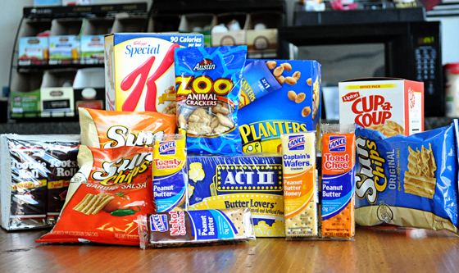

2 hours to race
- Animal crackers, granola bar, bagel, banana,
pretzels, graham crackers
- Water/Sports drink

1 Hour to Race
- Sports drink/water

Regional Meet Food Timeline

9:35 - Girls Race
-5:15 - Wake up and shake out
- 5:30 - Breakfast
-7:15 - Final snack and fluids
- 7:30 - Depart for course
- 8:15 - Walk course & final fluids
- 8:55 - Warm up
- 9:35 - Race
10:00 - Boys Race
-5:45 - Wake up and shake out
- 6:00 - Breakfast
- 7:30 - Depart for course
-8:00 - Final snack and fluids
- 8:30 - Walk course & final fluids
- 9:20 - Warm up
- 10:00 Race

Hydration
Hydration is an important element of a successful cross country season in order for us to achieve our maximum potential and gain an advantage over our opponents.
Body Weight Water Loss
2-4% - wt loss - reduced muscular endurance time (5% performance reduction)
4-6% - wt loss - reduced muscular strength & endurance, heat cramps (30% reduction in performance)
>6% - wt loss - severe heat cramps, heat exhaustion, heat stroke, coma, death

Before Meet / Practice
- 2 hours - 20 oz or more of water or sports drink

During Practice
- 4-6 oz every 15-20 min

After Practice/Meet
- 16-24 oz per pound lost
- Sip fluids don't chug
- Regain at least 80% of body weight

