Unit Test Government At Work

Multiple Choice
Identify the letter of the choice that best completes the statement or answers the question.

MAIN IDEAS

____ 1. According to the Constitution, the President must
a. | be a man who owns property.
b. | be at least 35 years of age.
c. | have held one major public office.
d. | have lived in the U. S. for at least 20 years.

____ 2. If an incumbent President is seeking another term in office, who will his party likely nominate?
a. | the Vice President | c. | the Speaker of the House
b. | the President | d. | the House majority leader

____ 3. The President may decide to resume duties after an illness by informing Congress that no inability exists, but that decision can be challenged by
a. | Congress.
b. | the Vice President.
c. | the Vice President and a majority of the Cabinet.
d. | any representative in the House of Representatives.

____ 4. The least number of presidential electors a State can have is
a. | one. | c. | three.
b. | two. | d. | four.

____ 5. The order of succession to the presidency after the Vice President is determined by the
a. | original Constitution. | c. | Presidential Succession Act.
b. | force of tradition. | d. | 25th Amendment.

____ 6. Which of the following is a way that presidential disability is determined?
a. | The Vice President and a majority of the Cabinet inform Congress in writing.
b. | The Senate states, in writing, that the President is incapacitated.
c. | The President gives a speech explaining who will take over.
d. | Congress asks the Vice President to evaluate the President's condition.

____ 7. A presidential primary can be
a. | a process to select delegates to the convention.
b. | an election to determine voters' choice among candidates.
c. | both of the above.
d. | none of the above.

____ 8. The first session of the national convention is generally devoted to
a. | voting for candidates. | c. | drafting the platform.
b. | giving speeches. | d. | reporting information.

____ 9. The most widely supported plan for reform of the electoral college is the
a. | district plan. | c. | direct popular election plan.
b. | proportional plan. | d. | national bonus plan.

____ 10. The major importance of the 12th Amendment is that it
a. | did away with the electoral college system.
b. | eliminated the possibility of a tie for the presidency.
c. | required electors to pledge to vote for their party's chosen candidate.
d. | made electors' votes automatic.

____ 11. Most of the sessions at the national convention are spent
a. | listening to the keynote address.
b. | electing the convention's committee members.
c. | selecting the party's presidential candidate.
d. | listening to party speeches and reports.

____ 12. The power of the presidency has been cause for debate MAINLY because
a. | the presidency is the most powerful office in the world.
b. | the Constitution provided a loose definition of executive power.
c. | the presidency is an office that operates in full view of the public.
d. | leaders wanted to prevent the President from becoming a tyrant.

____ 13. Which of the following has NOT worked to strengthen the powers of the presidency?
a. | the influence of strong Presidents
b. | the demands of the American people for strong leadership
c. | the constitutional system of checks and balances
d. | the need for decisive action during national emergencies

____ 14. Which of the following statements about the President's power of removal is TRUE?
a. | For those offices for which Senate approval is required for appointment, Senate consent is also required for removal.
b. | Any person holding office by presidential appointment with Senate consent must remain in that office until the Senate confirms a successor.
c. | Any person holding office by presidential appointment with Senate consent may be removed only for incompetence.
d. | As a general rule, the President may remove any officeholders he or she has appointed.

____ 15. The President's military powers
a. | are strictly limited to times of war.
b. | are shared with Congress.
c. | only apply to the use of the United States Army and its weapons.
d. | may never be used to keep the domestic peace.

____ 16. The President CANNOT exercise judicial power by
a. | granting amnesty to a group of law violators.
b. | reducing the length of a sentence.
c. | granting pardons in cases of impeachment.
d. | postponing the carrying out of a sentence.

____ 17. In essence, the ordinance power gives the President the right to
a. | organize the judicial branch. | c. | administer laws.
b. | set up offices. | d. | appoint federal employees.

____ 18. The President's power to execute the law covers
a. | all federal laws, whether or not the President agrees with them.
b. | only those federal laws that the President supports.
c. | only those laws that are described or implied in the Constitution.
d. | all the laws of foreign countries to which the United States sends aid.

____ 19. When President Andrew Johnson fired his secretary of war in 1867, he was following
a. | Congress's orders.
b. | a strict construction of the Constitution.
c. | senatorial courtesy.
d. | the unwritten rule that the President may remove whomever he appoints.

____ 20. Treaties can be
a. | declared unconstitutional by the Supreme Court.
b. | made with the Senate's consent.
c. | repealed by Congress.
d. | all of the above.

____ 21. Which of the following is NOT a reason for the growth of executive power?
a. | demands for limits on Federal Government roles
b. | the passage of thousands of laws by Congress
c. | mass media expansion
d. | the nation's complex economic life

____ 22. The President's power to grant pardons
a. | may be overridden by the Senate.
b. | applies to cases involving federal and State offenses.
c. | may be used in cases of impeachment.
d. | can be used before a person is charged with a crime.

____ 23. Some Presidents, such as ____, have taken a narrow view of presidential powers.
a. | Franklin Delanor Roosevelt | c. | William Howard Taft
b. | Theodore Roosevelt | d. | James Madison

____ 24. The Federal Government is considered a bureaucracy primarily because it
a. | was established according to the practice and traditions set by past Presidents as they fulfilled their executive functions.
b. | consists of many agencies that do not function very efficiently in the performance of their duties.
c. | is a complex system of organization based on certain principles.
d. | is headed by the President, who represents the main bureau, or office.

____ 25. Unlike staff agencies, line agencies
a. | serve in a support capacity by offering advice.
b. | are directly responsible for administering programs.
c. | help advise private programs of public interest.
d. | primarily assist in the overall management of the executive branch.

____ 26. The civil service was created partly to ensure that federal employees
a. | may run in partisan political elections.
b. | are promoted based on loyalty to a political party.
c. | are allowed full participation in party activities.
d. | are promoted based on merit.

____ 27. Historically, the role of the Cabinet in the President's decision making may be described as
a. | dependent on a President's use of it.
b. | essential to the presidency.
c. | unnecessary and a waste of time.
d. | a key factor in the Framers' thinking.

____ 28. Over time, the number of executive departments grew in large part because
a. | Presidents wanted more secretaries in the Cabinet.
b. | the major political parties voted to expand the number of executive departments.
c. | regional offices were closed and departments opened in Washington.
d. | the workload of the Federal Government expanded as the country grew.

____ 29. Which one of the following agencies is a part of the Executive Office of the President?
a. | Social Security Administration
b. | Office of Management and Budget
c. | Federal Deposit Insurance Corporation
d. | Nuclear Regulatory Commission

____ 30. The power to borrow money, historically, was seen as a way for the United States to
a. | get the money needed to operate on a day-to-day basis.
b. | meet the costs of both long and short term crisis situations.
c. | demonstrate its financial power to other countries of the world.
d. | finance projects that could just as easily have been supported by taxes.

____ 31. One reason for the importance of the federal budget is that it
a. | determines how Social Security will be distributed.
b. | demonstrates Congress' stand on significant issues.
c. | determines which public programs will have money to operate.
d. | limits the sources from which budget money can come.

____ 32. Which of the following limits on the Federal Government's power to tax is implied but not stated in the Constitution?
a. | No tax shall be levied on articles exported from any State.
b. | All taxes must be used for public purposes, not private purposes.
c. | States shall not be taxed for their governmental activities.
d. | States shall pay direct taxes proportionately based on population.

____ 33. The Federal Government can levy taxes on all of the following groups EXCEPT
a. | manufacturers. | c. | churches.
b. | workers. | d. | importers.

____ 34. A gift tax must be paid if a person
a. | receives money from the estate of a deceased relative.
b. | receives gifts valuing more than $10,000 in any one year.
c. | imports certain luxury items.
d. | receives gifts of more than $100,000 in a lifetime, paid in increments of $10,000 per year.

____ 35. The Federal Government is able to borrow money at lower interest rates than private borrowers because
a. | its securities are considered the safest possible investment.
b. | interest rates are set by Congress.
c. | it borrows over long periods of time.
d. | it borrows mostly from State governments.

____ 36. Both corporate and individual income taxes are set at ____ rates.
a. | high | c. | regressive
b. | progressive | d. | low

____ 37. The Federal Government can
a. | use its taxing power in any manner it wishes.
b. | tax an activity that Congress believes is harmful or dangerous to the public.
c. | not levy taxes for any reason other than to raise money.
d. | tax a State government on its public service activities.

____ 38. Canal tolls and fees for passports and patents are categorized as
a. | custom duties. | c. | seigniorage.
b. | excise taxes. | d. | nontax revenues.

____ 39. In recent decades, the Federal Government borrowed money mostly to
a. | finance special expensive projects.
b. | provide funds for crisis situations, such as wars and natural disasters.
c. | pay the President's salary.
d. | operate the government and pay previous years' debt.

____ 40. During the cold war, American relations with the Soviet Union were dominated by
a. | détente. | c. | containment.
b. | foreign aid. | d. | collective security.

____ 41. A major feature of American foreign policy since World War II has been
a. | deterrence.
b. | the Roosevelt Corollary to the Monroe Doctrine.
c. | support for the League of Nations.
d. | renewed isolationism.

____ 42. Since 1965 the immigration policy of the United States, as enforced by the Immigration and Naturalization Service, has emphasized
a. | ethnicity and nationality.
b. | economic and social status.
c. | refugee status and family reunification.
d. | health and intelligence assessment.

____ 43. Which does NOT accurately describe the secretary of defense?
a. | operating head of the Defense Department
b. | President's chief aide in making and carrying out defense policy
c. | headquartered in the Pentagon
d. | must have served active military duty within 10 years of appointment

____ 44. The United States Public Health Service has a role in foreign affairs by
a. | deporting those who try to enter this country with contagious diseases.
b. | patrolling U.S. borders to prevent germ warfare.
c. | working with the United Nations to prevent disease and meet other health related problems throughout the world.
d. | developing new strains of disease to counter terrorists.

____ 45. Which of the following best describes the role of the secretary of state?
a. | the President's chief aide and advisor in making and carrying out defense policy
b. | the operating head of the Defense Department
c. | the President's chief aide and advisor on matters of foreign affairs
d. | to publish the nation's laws, issue patents, and supervise the census

____ 46. The duties of the Immigration and Naturalization Service include
a. | issuing work permits to immigrants.
b. | granting asylum to political refugees.
c. | preparing applicants for U.S. citizenship.
d. | all of the above.

____ 47. For the first part of the country's history, American foreign policy could be described most accurately as
a. | a continued involvement in all aspects of world affairs.
b. | a pursuit of numerous economic and diplomatic ties abroad.
c. | a desire for noninvolvement.
d. | maintaining world leadership.

INTERPRETING MAPS
Use the map to answer the following questions.

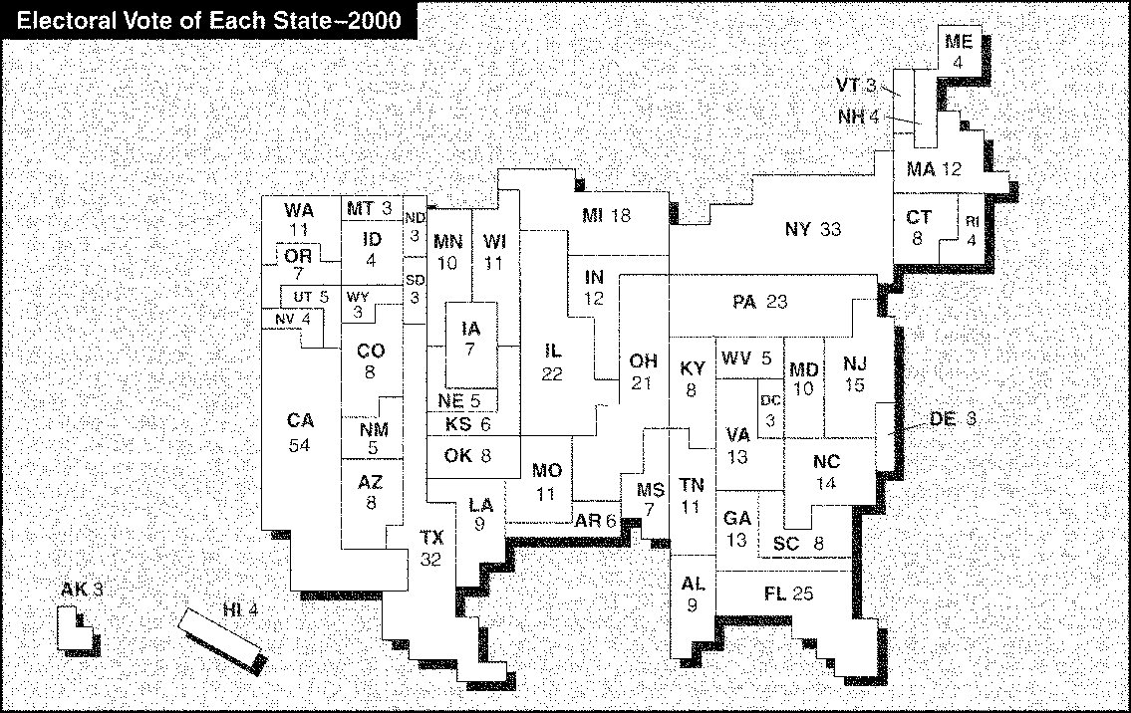

____ 48. The States with the largest electoral vote include
a. | Pennsylvania and Illinois. | c. | Texas and Florida.
b. | Alaska and Hawaii. | d. | California and New York.

INTERPRETING POLITICAL CARTOONS
Use the cartoon to answer the following questions.

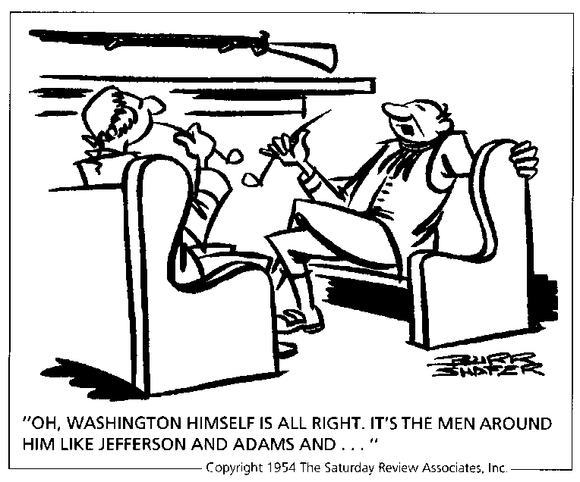

____ 49. Which of the following statements seems to explain best the point the cartoonist is trying to make?
a. | Jefferson would make a worse President than Washington.
b. | Washington made some foolish political appointments.
c. | Criticism of the President's Cabinet has been common since the earliest days of the nation.
d. | Popular feeling grew up against Washington because of his Cabinet.

INTERPRETING GRAPHS
Use the graph to answer the following questions.

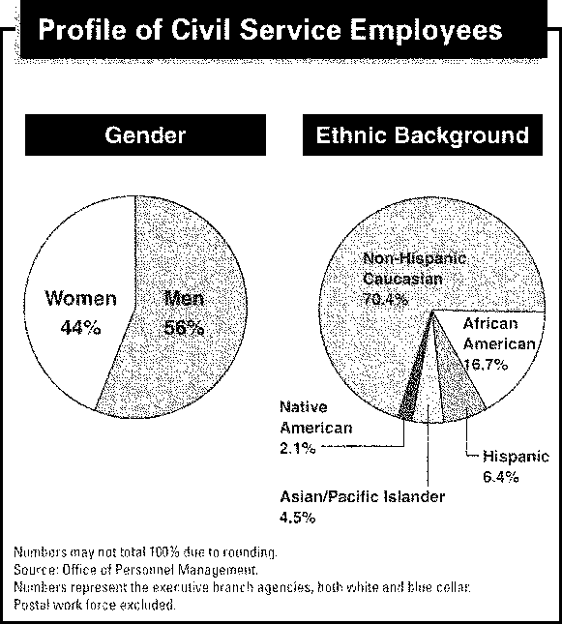

____ 50. What percentage of civil service employees are Hispanic?
a. | 16.7% | c. | 4.5%
b. | 6.4% | d. | 2%

